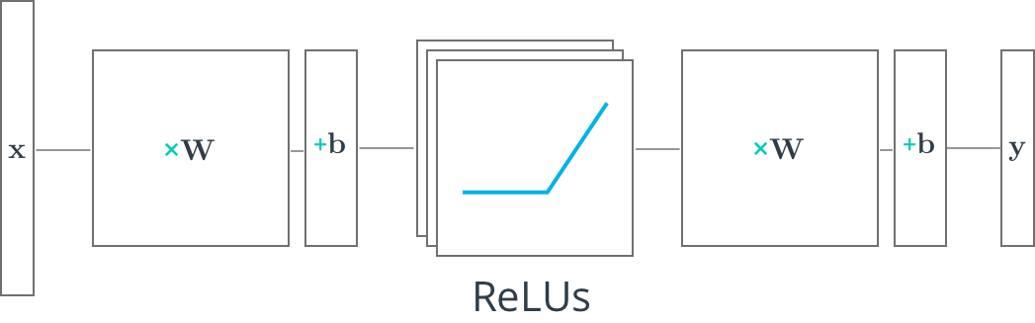

**Multilayer Neural Networks**

In this lesson, you'll learn how to build multilayer neural networks with TensorFlow. From before, you should know that adding a hidden layer to a network allows it to model more complex functions. Also, using a non-linear activation function on the hidden layer lets it model non-linear functions.

You've already learned about a non-linear function, the ReLU or rectified linear unit. The ReLU function is 0 for negative inputs and *x* for all inputs *x*>0. If you need a refresher, check out the Intro to TFLearn lesson.

Next, you'll see how a ReLU hidden layer is implemented in TensorFlow.

# TensorFlow ReLUs

TensorFlow provides the ReLU function as [**tf.nn.relu()**](https://www.tensorflow.org/api_docs/python/tf/nn/relu), as shown below.

*# Hidden Layer with ReLU activation function*

hidden_layer = tf.add(tf.matmul(features, hidden_weights), hidden_biases)

hidden_layer = tf.nn.relu(hidden_layer)

output = tf.add(tf.matmul(hidden_layer, output_weights), output_biases)

The above code applies the [**tf.nn.relu()**](https://www.tensorflow.org/api_docs/python/tf/nn/relu) function to the hidden_layer, effectively turning off any negative weights and acting like an on/off switch. Adding additional layers, like the output layer, after an activation function turns the model into a nonlinear function. This nonlinearity allows the network to solve more complex problems.

## Quiz

Below you'll use the ReLU function to turn a linear single layer network into a non-linear multilayer network.

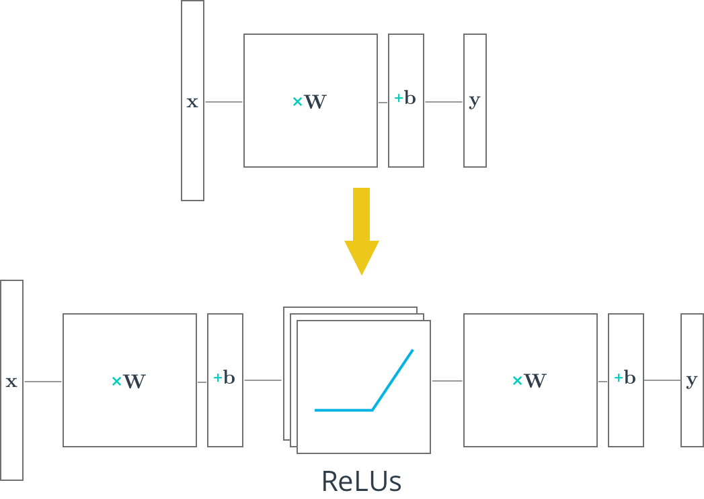

# Deep Neural Network in TensorFlow

You've seen how to build a logistic classifier using TensorFlow. Now you're going to see how to use the logistic classifier to build a deep neural network.

## Step by Step

In the following walkthrough, we'll step through TensorFlow code written to classify the letters in the MNIST database. If you would like to run the network on your computer, the file is provided [**here**](https://d17h27t6h515a5.cloudfront.net/topher/2017/February/58a61a3a_multilayer-perceptron/multilayer-perceptron.zip). You can find this and many more examples of TensorFlow at [**Aymeric Damien's GitHub repository**](https://github.com/aymericdamien/TensorFlow-Examples).

## Code

### TensorFlow MNIST

**from** tensorflow.examples.tutorials.mnist **import** input_data

mnist = input_data.read_data_sets(".", one_hot=**True**, reshape=**False**)

You'll use the MNIST dataset provided by TensorFlow, which batches and One-Hot encodes the data for you.

### Learning Parameters

**import** tensorflow **as** tf

*# Parameters*

learning_rate = 0.001

training_epochs = 20

batch_size = 128 *# Decrease batch size if you don't have enough memory*

display_step = 1

n_input = 784 *# MNIST data input (img shape: 28*28)*

n_classes = 10 *# MNIST total classes (0-9 digits)*

The focus here is on the architecture of multilayer neural networks, not parameter tuning, so here we'll just give you the learning parameters.

### Hidden Layer Parameters

n_hidden_layer = 256 *# layer number of features*

The variable n_hidden_layer determines the size of the hidden layer in the neural network. This is also known as the width of a layer.

### Weights and Biases

*# Store layers weight & bias*

weights = {

'hidden_layer': tf.Variable(tf.random_normal([n_input, n_hidden_layer])),

'out': tf.Variable(tf.random_normal([n_hidden_layer, n_classes]))

}

biases = {

'hidden_layer': tf.Variable(tf.random_normal([n_hidden_layer])),

'out': tf.Variable(tf.random_normal([n_classes]))

}

Deep neural networks use multiple layers with each layer requiring it's own weight and bias. The 'hidden_layer' weight and bias is for the hidden layer. The 'out' weight and bias is for the output layer. If the neural network were deeper, there would be weights and biases for each additional layer.

### Input

*# tf Graph input*

x = tf.placeholder("float", [**None**, 28, 28, 1])

y = tf.placeholder("float", [**None**, n_classes])

x_flat = tf.reshape(x, [-1, n_input])

The MNIST data is made up of 28px by 28px images with a single [**channel**](https://en.wikipedia.org/wiki/Channel_(digital_image%29). The [**tf.reshape()**](https://www.tensorflow.org/api_docs/python/array_ops/shapes_and_shaping#reshape) function above reshapes the 28px by 28px matrices in x into vectors of 784px by 1px.

### Multilayer Perceptron

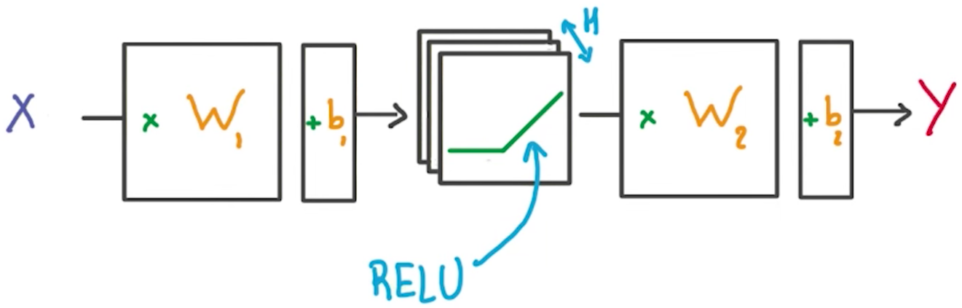

*# Hidden layer with RELU activation*

layer_1 = tf.add(tf.matmul(x_flat, weights['hidden_layer']),\

biases['hidden_layer'])

layer_1 = tf.nn.relu(layer_1)

*# Output layer with linear activation*

logits = tf.add(tf.matmul(layer_1, weights['out']), biases['out'])

You've seen the linear function tf.add(tf.matmul(x_flat, weights['hidden_layer']), biases['hidden_layer']) before, also known as xw + b. Combining linear functions together using a ReLU will give you a two layer network.

### Optimizer

*# Define loss and optimizer*

cost = tf.reduce_mean(\

tf.nn.softmax_cross_entropy_with_logits(logits=logits, labels=y))

optimizer = tf.train.GradientDescentOptimizer(learning_rate=learning_rate)\

.minimize(cost)

This is the same optimization technique used in the Intro to TensorFLow lab.

### Session

*# Initializing the variables*

init = tf.global_variables_initializer()

*# Launch the graph*

**with** tf.Session() **as** sess:

sess.run(init)

*# Training cycle*

**for** epoch **in** range(training_epochs):

total_batch = int(mnist.train.num_examples/batch_size)

*# Loop over all batches*

**for** i **in** range(total_batch):

batch_x, batch_y = mnist.train.next_batch(batch_size)

*# Run optimization op (backprop) and cost op (to get loss value)*

sess.run(optimizer, feed_dict={x: batch_x, y: batch_y})

The MNIST library in TensorFlow provides the ability to receive the dataset in batches. Calling the mnist.train.next_batch() function returns a subset of the training data.

## Deeper Neural Network

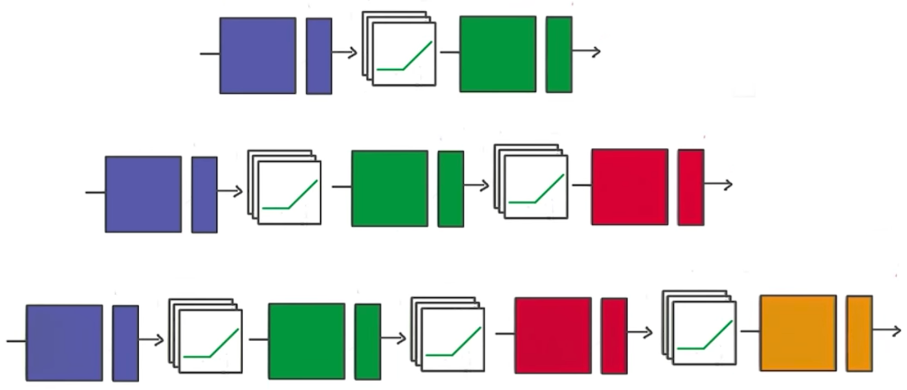

That's it! Going from one layer to two is easy. Adding more layers to the network allows you to solve more complicated problems. In the next video, you'll see how changing the number of layers can affect your network.

# Save and Restore TensorFlow Models

Training a model can take hours. But once you close your TensorFlow session, you lose all the trained weights and biases. If you were to reuse the model in the future, you would have to train it all over again!

Fortunately, TensorFlow gives you the ability to save your progress using a class called [**tf.train.Saver**](https://www.tensorflow.org/api_docs/python/tf/train/Saver). This class provides the functionality to save any [**tf.Variable**](https://www.tensorflow.org/api_docs/python/tf/Variable) to your file system.

## Saving Variables

Let's start with a simple example of saving weights and bias Tensors. For the first example you'll just save two variables. Later examples will save all the weights in a practical model.

**import** tensorflow **as** tf

*# The file path to save the data*

save_file = './model.ckpt'

*# Two Tensor Variables: weights and bias*

weights = tf.Variable(tf.truncated_normal([2, 3]))

bias = tf.Variable(tf.truncated_normal([3]))

*# Class used to save and/or restore Tensor Variables*

saver = tf.train.Saver()

**with** tf.Session() **as** sess:

*# Initialize all the Variables*

sess.run(tf.global_variables_initializer())

*# Show the values of weights and bias*

print('Weights:')

print(sess.run(weights))

print('Bias:')

print(sess.run(bias))

*# Save the model*

saver.save(sess, save_file)

Weights:

[[-0.97990924 1.03016174 0.74119264]

[-0.82581609 -0.07361362 -0.86653847]]

Bias:

[ 1.62978125 -0.37812829 0.64723819]

The Tensors weights and bias are set to random values using the [**tf.truncated_normal()**](https://www.tensorflow.org/api_docs/python/tf/truncated_normal) function. The values are then saved to the save_file location, "model.ckpt", using the [**tf.train.Saver.save()**](https://www.tensorflow.org/api_docs/python/tf/train/Saver#save)function. (The ".ckpt" extension stands for "checkpoint".)

If you're using TensorFlow 0.11.0RC1 or newer, a file called "model.ckpt.meta" will also be created. This file contains the TensorFlow graph.

## Loading Variables

Now that the Tensor Variables are saved, let's load them back into a new model.

*# Remove the previous weights and bias*

tf.reset_default_graph()

*# Two Variables: weights and bias*

weights = tf.Variable(tf.truncated_normal([2, 3]))

bias = tf.Variable(tf.truncated_normal([3]))

*# Class used to save and/or restore Tensor Variables*

saver = tf.train.Saver()

**with** tf.Session() **as** sess:

*# Load the weights and bias*

saver.restore(sess, save_file)

*# Show the values of weights and bias*

print('Weight:')

print(sess.run(weights))

print('Bias:')

print(sess.run(bias))

Weights:

[[-0.97990924 1.03016174 0.74119264]

[-0.82581609 -0.07361362 -0.86653847]]

Bias:

[ 1.62978125 -0.37812829 0.64723819]

You'll notice you still need to create the weights and bias Tensors in Python. The [**tf.train.Saver.restore()**](https://www.tensorflow.org/api_docs/python/tf/train/Saver#restore) function loads the saved data into weights and bias.

Since [**tf.train.Saver.restore()**](https://www.tensorflow.org/api_docs/python/tf/train/Saver#restore) sets all the TensorFlow Variables, you don't need to call [**tf.global_variables_initializer()**](https://www.tensorflow.org/api_docs/python/tf/global_variables_initializer).

## Save a Trained Model

Let's see how to train a model and save its weights.

First start with a model:

*# Remove previous Tensors and Operations*

tf.reset_default_graph()

**from** tensorflow.examples.tutorials.mnist **import** input_data

**import** numpy **as** np

learning_rate = 0.001

n_input = 784 *# MNIST data input (img shape: 28*28)*

n_classes = 10 *# MNIST total classes (0-9 digits)*

*# Import MNIST data*

mnist = input_data.read_data_sets('.', one_hot=**True**)

*# Features and Labels*

features = tf.placeholder(tf.float32, [**None**, n_input])

labels = tf.placeholder(tf.float32, [**None**, n_classes])

*# Weights & bias*

weights = tf.Variable(tf.random_normal([n_input, n_classes]))

bias = tf.Variable(tf.random_normal([n_classes]))

*# Logits - xW + b*

logits = tf.add(tf.matmul(features, weights), bias)

*# Define loss and optimizer*

cost = tf.reduce_mean(\

tf.nn.softmax_cross_entropy_with_logits(logits=logits, labels=labels))

optimizer = tf.train.GradientDescentOptimizer(learning_rate=learning_rate)\

.minimize(cost)

*# Calculate accuracy*

correct_prediction = tf.equal(tf.argmax(logits, 1), tf.argmax(labels, 1))

accuracy = tf.reduce_mean(tf.cast(correct_prediction, tf.float32))

Let's train that model, then save the weights:

**import** math

save_file = './train_model.ckpt'

batch_size = 128

n_epochs = 100

saver = tf.train.Saver()

*# Launch the graph*

**with** tf.Session() **as** sess:

sess.run(tf.global_variables_initializer())

*# Training cycle*

**for** epoch **in** range(n_epochs):

total_batch = math.ceil(mnist.train.num_examples / batch_size)

*# Loop over all batches*

**for** i **in** range(total_batch):

batch_features, batch_labels = mnist.train.next_batch(batch_size)

sess.run(

optimizer,

feed_dict={features: batch_features, labels: batch_labels})

*# Print status for every 10 epochs*

**if** epoch % 10 == 0:

valid_accuracy = sess.run(

accuracy,

feed_dict={

features: mnist.validation.images,

labels: mnist.validation.labels})

print('Epoch {:<3} - Validation Accuracy: {}'.format(

epoch,

valid_accuracy))

*# Save the model*

saver.save(sess, save_file)

print('Trained Model Saved.')

Epoch 0 - Validation Accuracy: 0.06859999895095825

Epoch 10 - Validation Accuracy: 0.20239999890327454

Epoch 20 - Validation Accuracy: 0.36980000138282776

Epoch 30 - Validation Accuracy: 0.48820000886917114

Epoch 40 - Validation Accuracy: 0.5601999759674072

Epoch 50 - Validation Accuracy: 0.6097999811172485

Epoch 60 - Validation Accuracy: 0.6425999999046326

Epoch 70 - Validation Accuracy: 0.6733999848365784

Epoch 80 - Validation Accuracy: 0.6916000247001648

Epoch 90 - Validation Accuracy: 0.7113999724388123

Trained Model Saved.

## Load a Trained Model

Let's load the weights and bias from memory, then check the test accuracy.

saver = tf.train.Saver()

*# Launch the graph*

**with** tf.Session() **as** sess:

saver.restore(sess, save_file)

test_accuracy = sess.run(

accuracy,

feed_dict={features: mnist.test.images, labels: mnist.test.labels})

print('Test Accuracy: {}'.format(test_accuracy))

Test Accuracy: 0.7229999899864197

That's it! You now know how to save and load a trained model in TensorFlow. Let's look at loading weights and biases into modified models in the next section.

# Loading the Weights and Biases into a New Model

Sometimes you might want to adjust, or "finetune" a model that you have already trained and saved.

However, loading saved Variables directly into a modified model can generate errors. Let's go over how to avoid these problems.

## Naming Error

TensorFlow uses a string identifier for Tensors and Operations called name. If a name is not given, TensorFlow will create one automatically. TensorFlow will give the first node the name <Type>, and then give the name <Type>_<number> for the subsequent nodes. Let's see how this can affect loading a model with a different order of weights and bias:

**import** tensorflow **as** tf

*# Remove the previous weights and bias*

tf.reset_default_graph()

save_file = 'model.ckpt'

*# Two Tensor Variables: weights and bias*

weights = tf.Variable(tf.truncated_normal([2, 3]))

bias = tf.Variable(tf.truncated_normal([3]))

saver = tf.train.Saver()

*# Print the name of Weights and Bias*

print('Save Weights: {}'.format(weights.name))

print('Save Bias: {}'.format(bias.name))

**with** tf.Session() **as** sess:

sess.run(tf.global_variables_initializer())

saver.save(sess, save_file)

*# Remove the previous weights and bias*

tf.reset_default_graph()

*# Two Variables: weights and bias*

bias = tf.Variable(tf.truncated_normal([3]))

weights = tf.Variable(tf.truncated_normal([2, 3]))

saver = tf.train.Saver()

*# Print the name of Weights and Bias*

print('Load Weights: {}'.format(weights.name))

print('Load Bias: {}'.format(bias.name))

**with** tf.Session() **as** sess:

*# Load the weights and bias - ERROR*

saver.restore(sess, save_file)

The code above prints out the following:

Save Weights: Variable:0

Save Bias: Variable_1:0

Load Weights: Variable_1:0

Load Bias: Variable:0

...

InvalidArgumentError (see above for traceback): Assign requires shapes of both tensors to match.

...

You'll notice that the name properties for weights and bias are different than when you saved the model. This is why the code produces the "Assign requires shapes of both tensors to match" error. The code saver.restore(sess, save_file) is trying to load weight data into bias and bias data into weights.

Instead of letting TensorFlow set the name property, let's set it manually:

**import** tensorflow **as** tf

tf.reset_default_graph()

save_file = 'model.ckpt'

*# Two Tensor Variables: weights and bias*

weights = tf.Variable(tf.truncated_normal([2, 3]), name='weights_0')

bias = tf.Variable(tf.truncated_normal([3]), name='bias_0')

saver = tf.train.Saver()

*# Print the name of Weights and Bias*

print('Save Weights: {}'.format(weights.name))

print('Save Bias: {}'.format(bias.name))

**with** tf.Session() **as** sess:

sess.run(tf.global_variables_initializer())

saver.save(sess, save_file)

*# Remove the previous weights and bias*

tf.reset_default_graph()

*# Two Variables: weights and bias*

bias = tf.Variable(tf.truncated_normal([3]), name='bias_0')

weights = tf.Variable(tf.truncated_normal([2, 3]) ,name='weights_0')

saver = tf.train.Saver()

*# Print the name of Weights and Bias*

print('Load Weights: {}'.format(weights.name))

print('Load Bias: {}'.format(bias.name))

**with** tf.Session() **as** sess:

*# Load the weights and bias - No Error*

saver.restore(sess, save_file)

print('Loaded Weights and Bias successfully.')

Save Weights: weights_0:0

Save Bias: bias_0:0

Load Weights: weights_0:0

Load Bias: bias_0:0

Loaded Weights and Bias successfully.

That worked! The Tensor names match and the data loaded correctly.

# TensorFlow Dropout

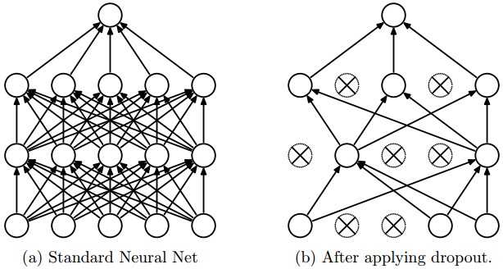

Figure 1: Taken from the paper "Dropout: A Simple Way to Prevent Neural Networks from Overfitting" ([**https://www.cs.toronto.edu/~hinton/absps/JMLRdropout.pdf**](https://www.cs.toronto.edu/~hinton/absps/JMLRdropout.pdf))

Dropout is a regularization technique for reducing overfitting. The technique temporarily drops units ([**artificial neurons**](https://en.wikipedia.org/wiki/Artificial_neuron)) from the network, along with all of those units' incoming and outgoing connections. Figure 1 illustrates how dropout works.

TensorFlow provides the [**tf.nn.dropout()**](https://www.tensorflow.org/api_docs/python/tf/nn/dropout) function, which you can use to implement dropout.

Let's look at an example of how to use [**tf.nn.dropout()**](https://www.tensorflow.org/api_docs/python/tf/nn/dropout).

keep_prob = tf.placeholder(tf.float32) *# probability to keep units*

hidden_layer = tf.add(tf.matmul(features, weights[0]), biases[0])

hidden_layer = tf.nn.relu(hidden_layer)

hidden_layer = tf.nn.dropout(hidden_layer, keep_prob)

logits = tf.add(tf.matmul(hidden_layer, weights[1]), biases[1])

The code above illustrates how to apply dropout to a neural network.

The [**tf.nn.dropout()**](https://www.tensorflow.org/api_docs/python/tf/nn/dropout) function takes in two parameters:

1. hidden_layer: the tensor to which you would like to apply dropout
2. keep_prob: the probability of keeping (i.e. not dropping) any given unit

keep_prob allows you to adjust the number of units to drop. In order to compensate for dropped units, [**tf.nn.dropout()**](https://www.tensorflow.org/api_docs/python/tf/nn/dropout) multiplies all units that are kept (i.e. not dropped) by 1/keep_prob.

During training, a good starting value for keep_prob is 0.5.

During testing, use a keep_prob value of 1.0 to keep all units and maximize the power of the model.

## Quiz 1

Take a look at the code snippet below. Do you see what's wrong?

There's nothing wrong with the syntax, however the test accuracy is extremely low.

...

keep_prob = tf.placeholder(tf.float32) *# probability to keep units*

hidden_layer = tf.add(tf.matmul(features, weights[0]), biases[0])

hidden_layer = tf.nn.relu(hidden_layer)

hidden_layer = tf.nn.dropout(hidden_layer, keep_prob)

logits = tf.add(tf.matmul(hidden_layer, weights[1]), biases[1])

...

**with** tf.Session() **as** sess:

sess.run(tf.global_variables_initializer())

**for** epoch_i **in** range(epochs):

**for** batch_i **in** range(batches):

....

sess.run(optimizer, feed_dict={

features: batch_features,

labels: batch_labels,

keep_prob: 0.5})

validation_accuracy = sess.run(accuracy, feed_dict={

features: test_features,

labels: test_labels,

keep_prob: 0.5})

### **QUESTION 1 OF 2**

What's wrong with the above code?

* 

Dropout doesn't work with batching.

* 

The keep_prob value of 0.5 is too low.

* 

There shouldn't be a value passed to keep_prob when testing for accuracy.

* 

keep_prob should be set to 1.0 when evaluating validation accuracy.

SUBMIT

## Quiz 2

This quiz will be starting with the code from the ReLU Quiz and applying a dropout layer. Build a model with a ReLU layer and dropout layer using the keep_prob placeholder to pass in a probability of 0.5. Print the logits from the model.

Note: Output will be different every time the code is run. This is caused by dropout randomizing the units it drops.

### CNN Intuition

Let's develop better intuition for how Convolutional Neural Networks (CNN) work. We'll examine how humans classify images, and then see how CNNs use similar approaches.

Let’s say we wanted to classify the following image of a dog as a Golden Retriever.

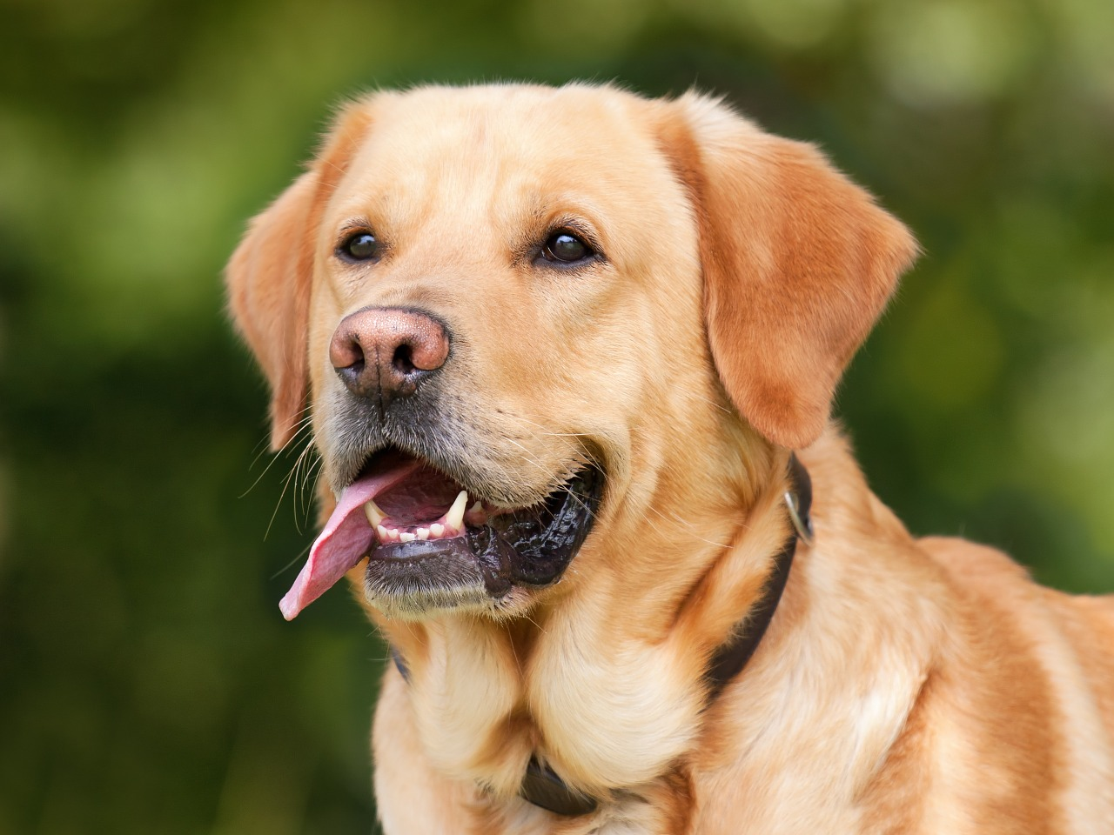

An image that we'd like to classify as a Golden Retriever.

As humans, how do we do this?

One thing we do is that we identify certain parts of the dog, such as the nose, the eyes, and the fur. We essentially break up the image into smaller pieces, recognize the smaller pieces, and then combine those pieces to get an idea of the overall dog.

In this case, we might break down the image into a combination of the following:

* A nose
* Two eyes
* Golden fur

These pieces can be seen below:

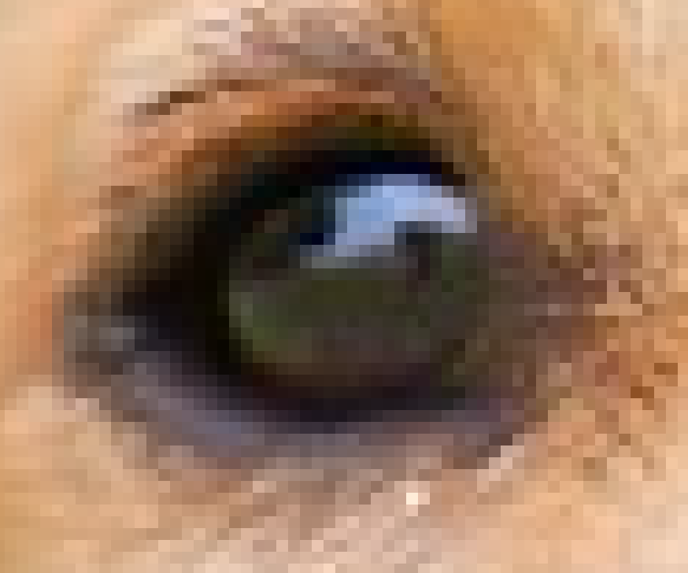

The eye of the dog.

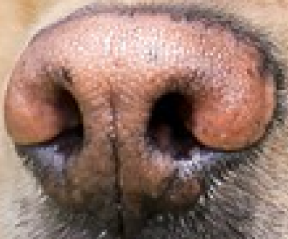

The nose of the dog.

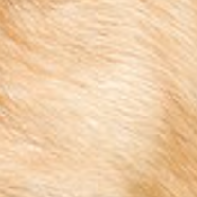

The fur of the dog.

### Going One Step Further

But let’s take this one step further. How do we determine what exactly a nose is? A Golden Retriever nose can be seen as an oval with two black holes inside it. Thus, one way of classifying a Retriever’s nose is to to break it up into smaller pieces and look for black holes (nostrils) and curves that define an oval as shown below.

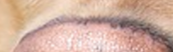

A curve that we can use to determine a nose.



A nostril that we can use to classify a nose of the dog.

Broadly speaking, this is what a CNN learns to do. It learns to recognize basic lines and curves, then shapes and blobs, and then increasingly complex objects within the image. Finally, the CNN classifies the image by combining the larger, more complex objects.

In our case, the levels in the hierarchy are:

* Simple shapes, like ovals and dark circles
* Complex objects (combinations of simple shapes), like eyes, nose, and fur
* The dog as a whole (a combination of complex objects)

With deep learning, we don't actually program the CNN to recognize these specific features. Rather, the CNN learns on its own to recognize such objects through forward propagation and backpropagation!

It's amazing how well a CNN can learn to classify images, even though we never program the CNN with information about specific features to look for.

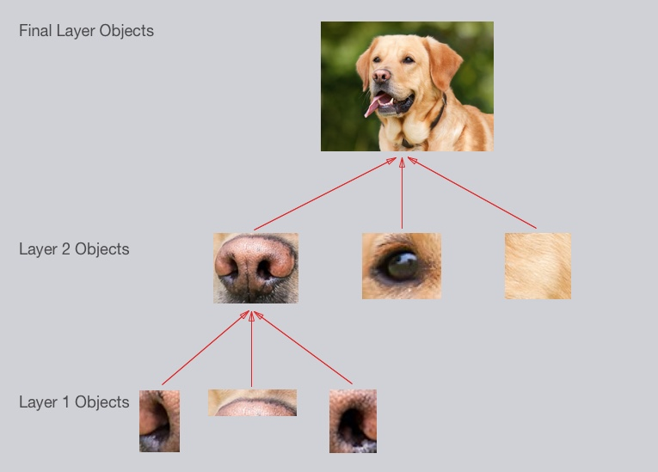

An example of what each layer in a CNN might recognize when classifying a picture of a dog.

A CNN might have several layers, and each layer might capture a different level in the hierarchy of objects. The first layer is the lowest level in the hierarchy, where the CNN generally classifies small parts of the image into simple shapes like horizontal and vertical lines and simple blobs of colors. The subsequent layers tend to be higher levels in the hierarchy and generally classify more complex ideas like shapes (combinations of lines), and eventually full objects like dogs.

Once again, the CNN **learns all of this on its own**. We don't ever have to tell the CNN to go looking for lines or curves or noses or fur. The CNN just learns from the training set and discovers which characteristics of a Golden Retriever are worth looking for.

That's a good start! Hopefully you've developed some intuition about how CNNs work.

Next, let’s look at some implementation details.

### Breaking up an Image

The first step for a CNN is to break up the image into smaller pieces. We do this by selecting a width and height that defines a filter.

The filter looks at small pieces, or patches, of the image. These patches are the same size as the filter.

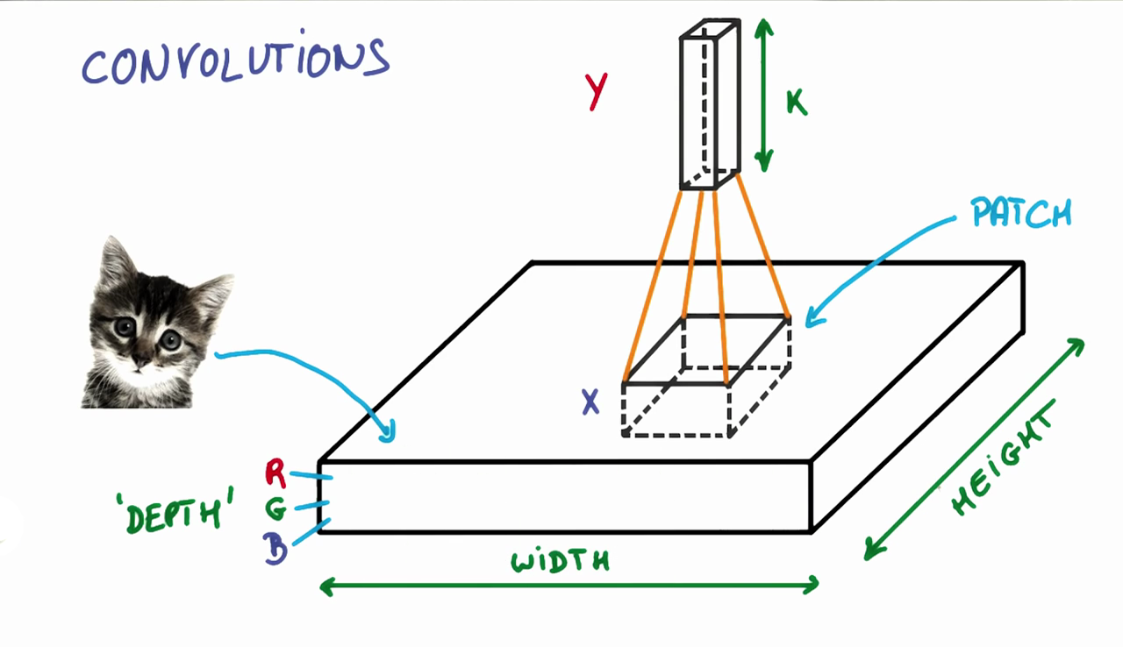

As shown in the previous video, a CNN uses filters to split an image into smaller patches. The size of these patches matches the filter size.

We then simply slide this filter horizontally or vertically to focus on a different piece of the image.

The amount by which the filter slides is referred to as the 'stride'. The stride is a hyperparameter which you, the engineer, can tune. Increasing the stride reduces the size of your model by reducing the number of total patches each layer observes. However, this usually comes with a reduction in accuracy.

Let’s look at an example. In this zoomed in image of the dog, we first start with the patch outlined in red. The width and height of our filter define the size of this square.

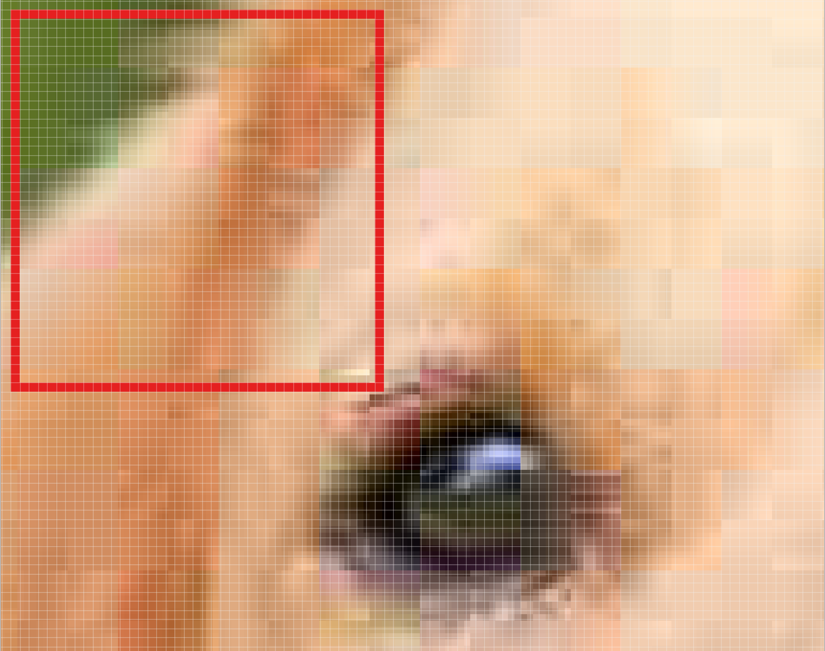

One patch of the Golden Retriever image.

We then move the square over to the right by a given stride (2 in this case) to get another patch.

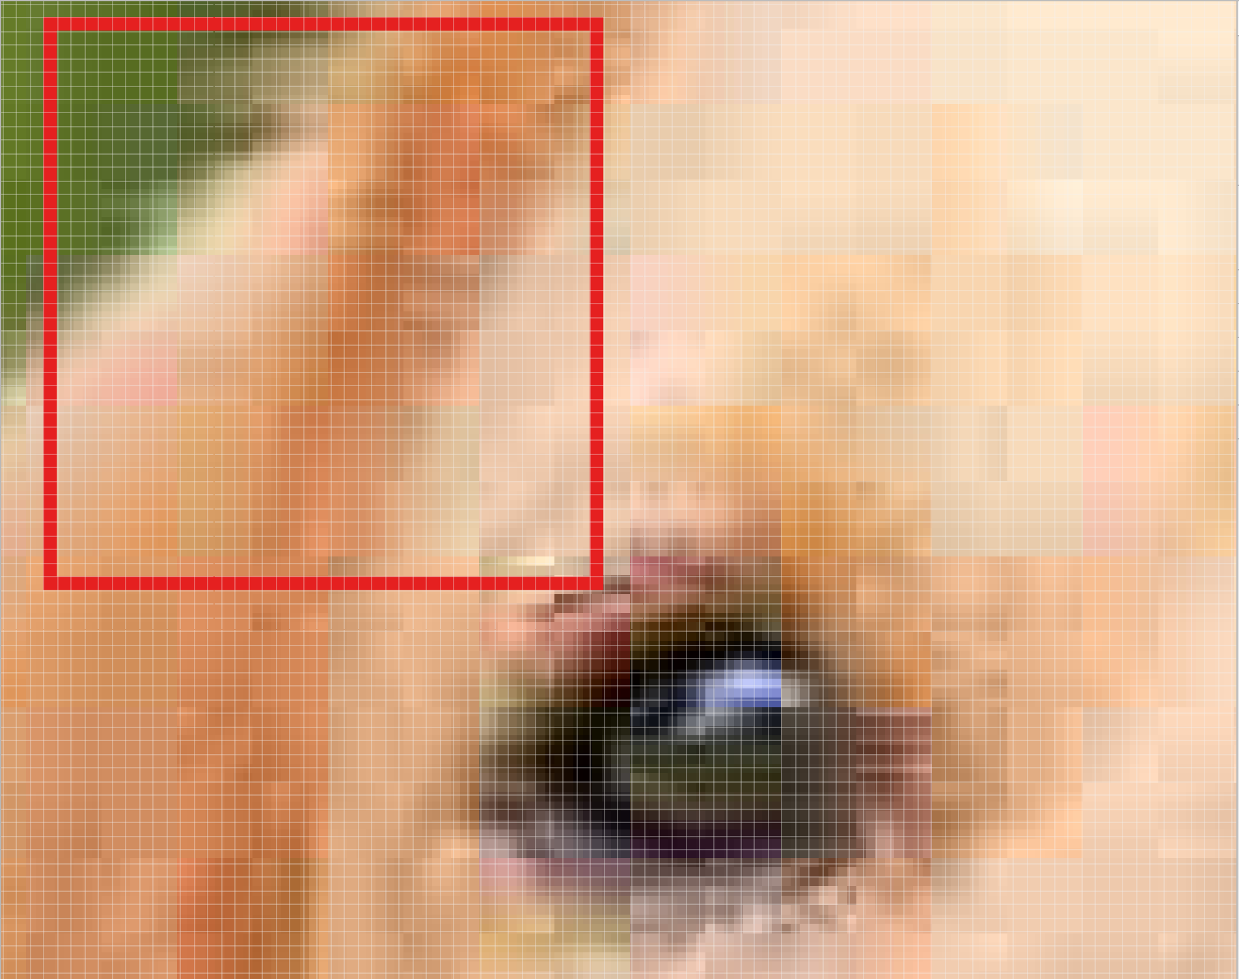

We move our square to the right by two pixels to create another patch.

What's important here is that we are **grouping together adjacent pixels** and treating them as a collective.

In a normal, non-convolutional neural network, we would have ignored this adjacency. In a normal network, we would have connected every pixel in the input image to a neuron in the next layer. In doing so, we would not have taken advantage of the fact that pixels in an image are close together for a reason and have special meaning.

By taking advantage of this local structure, our CNN learns to classify local patterns, like shapes and objects, in an image.

### Filter Depth

It's common to have more than one filter. Different filters pick up different qualities of a patch. For example, one filter might look for a particular color, while another might look for a kind of object of a specific shape. The amount of filters in a convolutional layer is called the filter depth.

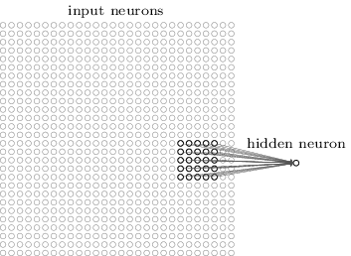

In the above example, a patch is connected to a neuron in the next layer. Source: MIchael Neilsen.

How many neurons does each patch connect to?

That’s dependent on our filter depth. If we have a depth of k, we connect each patch of pixels to k neurons in the next layer. This gives us the height of k in the next layer, as shown below. In practice, k is a hyperparameter we tune, and most CNNs tend to pick the same starting values.

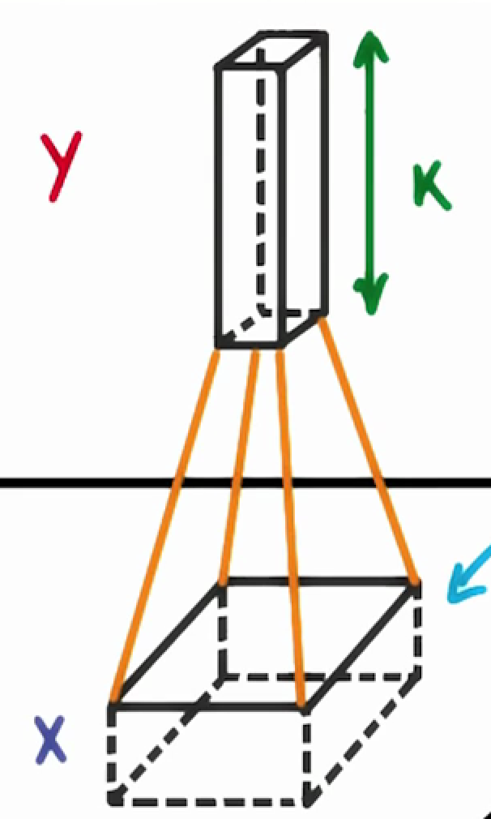

Choosing a filter depth of k connects each patch to k neurons in the next layer.

But why connect a single patch to multiple neurons in the next layer? Isn’t one neuron good enough?

Multiple neurons can be useful because a patch can have multiple interesting characteristics that we want to capture.

For example, one patch might include some white teeth, some blonde whiskers, and part of a red tongue. In that case, we might want a filter depth of at least three - one for each of teeth, whiskers, and tongue.

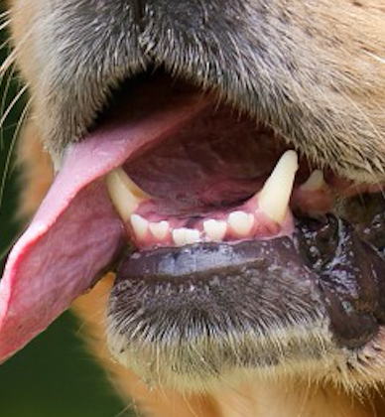

This patch of the dog has many interesting features we may want to capture. These include the presence of teeth, the presence of whiskers, and the pink color of the tongue.

Having multiple neurons for a given patch ensures that our CNN can learn to capture whatever characteristics the CNN learns are important.

Remember that the CNN isn't "programmed" to look for certain characteristics. Rather, it learns **on its own** which characteristics to notice.

### Parameter Sharing

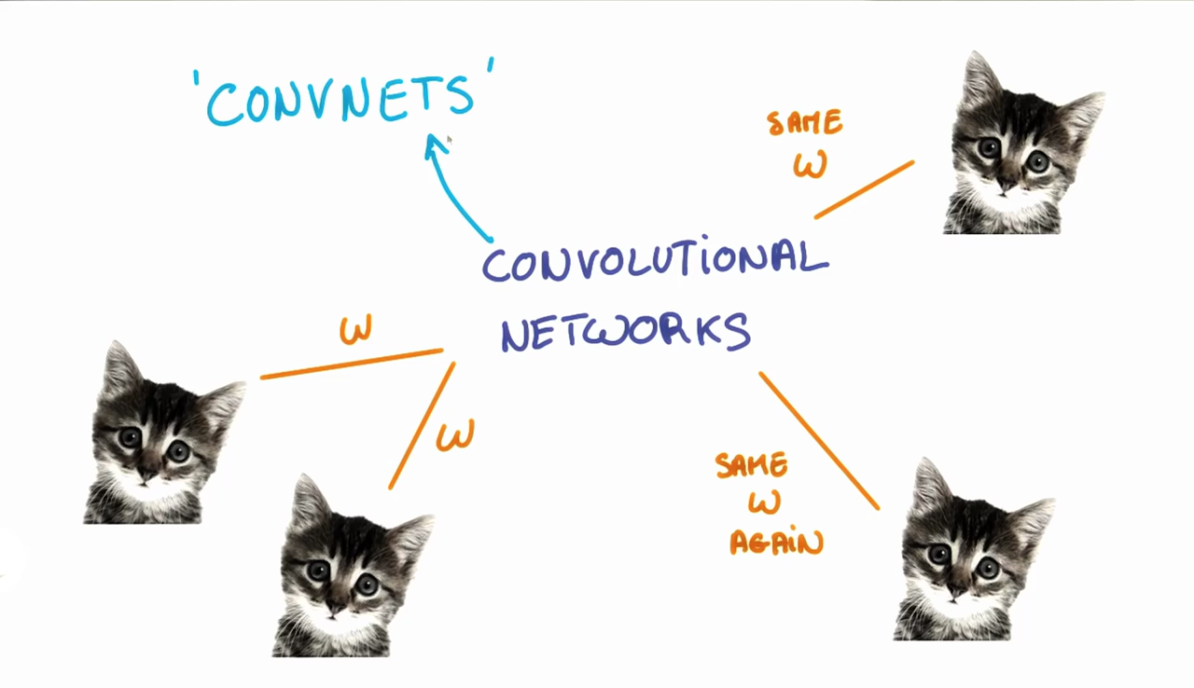

The weights, w, are shared across patches for a given layer in a CNN to detect the cat above regardless of where in the image it is located.

When we are trying to classify a picture of a cat, we don’t care where in the image a cat is. If it’s in the top left or the bottom right, it’s still a cat in our eyes. We would like our CNNs to also possess this ability known as translation invariance. How can we achieve this?

As we saw earlier, the classification of a given patch in an image is determined by the weights and biases corresponding to that patch.

If we want a cat that’s in the top left patch to be classified in the same way as a cat in the bottom right patch, we need the weights and biases corresponding to those patches to be the same, so that they are classified the same way.

This is exactly what we do in CNNs. The weights and biases we learn for a given output layer are shared across all patches in a given input layer. Note that as we increase the depth of our filter, the number of weights and biases we have to learn still increases, as the weights aren't shared across the output channels.

There’s an additional benefit to sharing our parameters. If we did not reuse the same weights across all patches, we would have to learn new parameters for every single patch and hidden layer neuron pair. This does not scale well, especially for higher fidelity images. Thus, sharing parameters not only helps us with translation invariance, but also gives us a smaller, more scalable model.

### Padding

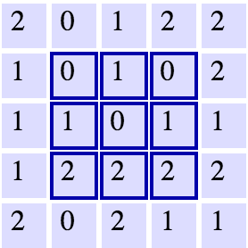

A 5x5 grid with a 3x3 filter. Source: Andrej Karpathy.

Let's say we have a 5x5 grid (as shown above) and a filter of size 3x3 with a stride of 1. What's the width and height of the next layer? We see that we can fit at most three patches in each direction, giving us a dimension of 3x3 in our next layer. As we can see, the width and height of each subsequent layer decreases in such a scheme.

In an ideal world, we'd be able to maintain the same width and height across layers so that we can continue to add layers without worrying about the dimensionality shrinking and so that we have consistency. How might we achieve this? One way is to simply add a border of 0s to our original 5x5 image. You can see what this looks like in the below image.

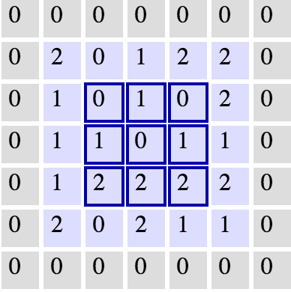

The same grid with 0 padding. Source: Andrej Karpathy.

This would expand our original image to a 7x7. With this, we now see how our next layer's size is again a 5x5, keeping our dimensionality consistent.

### Dimensionality

From what we've learned so far, how can we calculate the number of neurons of each layer in our CNN?

Given our input layer has a volume of W, our filter has a volume (height * width * depth) of F, we have a stride of S, and a padding of P, the following formula gives us the volume of the next layer: (W−F+2P)/S+1.

Knowing the dimensionality of each additional layer helps us understand how large our model is and how our decisions around filter size and stride affect the size of our network.

### Introduction

For the next few quizzes we'll test your understanding of the dimensions in CNNs. Understanding dimensions will help you make accurate tradeoffs between model size and performance. As you'll see, some parameters have a much bigger impact on model size than others.

### Setup

H = height, W = width, D = depth

* We have an input of shape 32x32x3 (HxWxD)
* 20 filters of shape 8x8x3 (HxWxD)
* A stride of 2 for both the height and width (S)
* Valid padding of size 1 (P)

Recall the formula for calculating the new height or width:

new_height = (input_height - filter_height + 2 * P)/S + 1

new_width = (input_width - filter_width + 2 * P)/S + 1

### Solution

The answer is **14x14x20**.

We can get the new height and width with the formula resulting in:

(32 - 8 + 2 * 1)/2 + 1 = 14

(32 - 8 + 2 * 1)/2 + 1 = 14

The new depth is equal to the number of filters, which is 20.

This would correspond to the following code:

input = tf.placeholder(tf.float32, (**None**, 32, 32, 3))

filter_weights = tf.Variable(tf.truncated_normal((8, 8, 3, 20))) *# (height, width, input_depth, output_depth)*

filter_bias = tf.Variable(tf.zeros(20))

strides = [1, 2, 2, 1] *# (batch, height, width, depth)*

padding = 'VALID'

conv = tf.nn.conv2d(input, filter_weights, strides, padding) + filter_bias

Note the output shape of conv will be [1, 13, 13, 20]. It's 4D to account for batch size, but more importantly, it's not [1, 14, 14, 20]. This is because the padding algorithm TensorFlow uses is not exactly the same as the one above. An alternative algorithm is to switch padding from 'VALID' to SAME which would result in an output shape of [1, 16, 16, 20]. If you're curious how padding works in TensorFlow, read [**this document**](https://www.tensorflow.org/api_guides/python/nn#Convolution).

We're now going to calculate the number of parameters of the convolutional layer. The answer from the last quiz will come into play here!

Being able to calculate the number of parameters in a neural network is useful since we want to have control over how much memory a neural network uses.

### Setup

H = height, W = width, D = depth

* We have an input of shape 32x32x3 (HxWxD)
* 20 filters of shape 8x8x3 (HxWxD)
* A stride of 2 for both the height and width (S)
* Zero padding of size 1 (P)

### Output Layer

* 14x14x20 (HxWxD)

### Hint

Without parameter sharing, each neuron in the output layer must connect to each neuron in the filter. In addition, each neuron in the output layer must also connect to a single bias neuron.

### Solution

There are 756560 total parameters. That's a HUGE amount! Here's how we calculate it:

(8 * 8 * 3 + 1) * (14 * 14 * 20) = 756560

8 * 8 * 3 is the number of weights, we add 1 for the bias. Remember, each weight is assigned to every single part of the output (14 * 14 * 20). So we multiply these two numbers together and we get the final answer.

ow we'd like you to calculate the number of parameters in the convolutional layer, if every neuron in the output layer shares its parameters with every other neuron in its same channel.

This is the number of parameters actually used in a convolution layer ([**tf.nn.conv2d()**](https://www.tensorflow.org/api_docs/python/tf/nn/conv2d)).

### Setup

H = height, W = width, D = depth

* We have an input of shape 32x32x3 (HxWxD)
* 20 filters of shape 8x8x3 (HxWxD)
* A stride of 2 for both the height and width (S)
* Zero padding of size 1 (P)

### Output Layer

* 14x14x20 (HxWxD)

### Hint

With parameter sharing, each neuron in an output channel shares its weights with every other neuron in that channel. So the number of parameters is equal to the number of neurons in the filter, plus a bias neuron, all multiplied by the number of channels in the output layer.

### Solution

There are 3860 total parameters. That's 196 times fewer parameters! Here's how the answer is calculated:

(8 * 8 * 3 + 1) * 20 = 3840 + 20 = 3860

That's 3840 weights and 20 biases. This should look similar to the answer from the previous quiz. The difference being it's just 20 instead of (14 * 14 * 20). Remember, with weight sharing we use the same filter for an entire depth slice. Because of this we can get rid of 14 * 14 and be left with only 20.

### Visualizing CNNs

Let’s look at an example CNN to see how it works in action.

The CNN we will look at is trained on ImageNet as described in [**this paper**](http://www.matthewzeiler.com/pubs/arxive2013/eccv2014.pdf) by Zeiler and Fergus. In the images below (from the same paper), we’ll see what each layer in this network detects and see how each layer detects more and more complex ideas.

### Layer 1

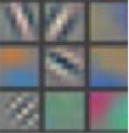

Example patterns that cause activations in the first layer of the network. These range from simple diagonal lines (top left) to green blobs (bottom middle).

The images above are from Matthew Zeiler and Rob Fergus' [**deep visualization toolbox**](https://www.youtube.com/watch?v=ghEmQSxT6tw), which lets us visualize what each layer in a CNN focuses on.

Each image in the above grid represents a pattern that causes the neurons in the first layer to activate - in other words, they are patterns that the first layer recognizes. The top left image shows a -45 degree line, while the middle top square shows a +45 degree line. These squares are shown below again for reference.

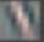

As visualized here, the first layer of the CNN can recognize -45 degree lines.

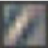

The first layer of the CNN is also able to recognize +45 degree lines, like the one above.

Let's now see some example images that cause such activations. The below grid of images all activated the -45 degree line. Notice how they are all selected despite the fact that they have different colors, gradients, and patterns.

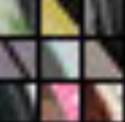

Example patches that activate the -45 degree line detector in the first layer.

So, the first layer of our CNN clearly picks out very simple shapes and patterns like lines and blobs.

### Layer 2

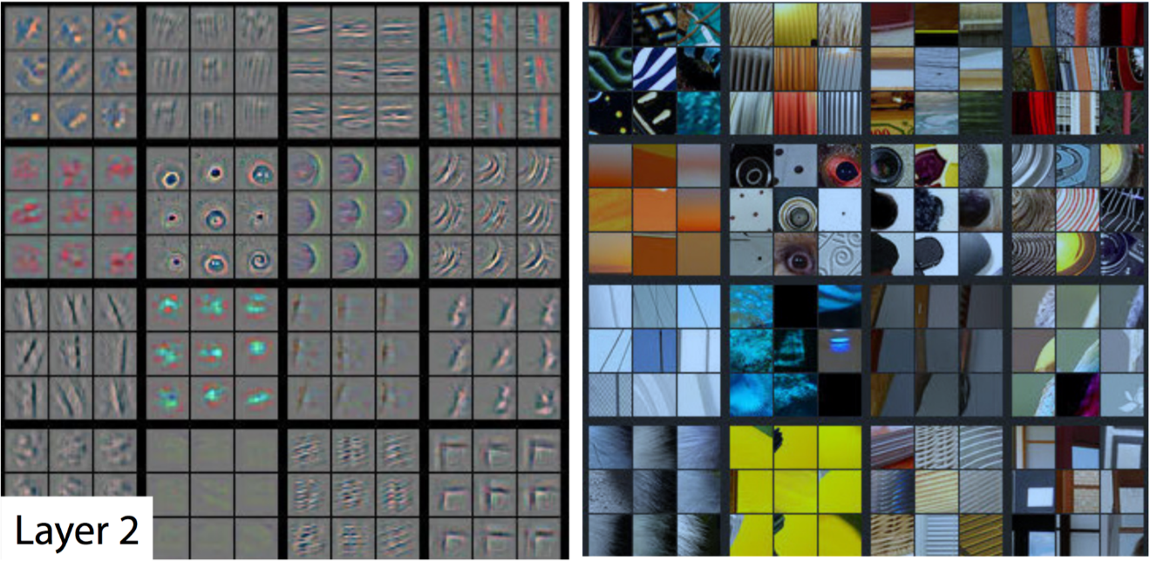

A visualization of the second layer in the CNN. Notice how we are picking up more complex ideas like circles and stripes. The gray grid on the left represents how this layer of the CNN activates (or "what it sees") based on the corresponding images from the grid on the right.

The second layer of the CNN captures complex ideas.

As you see in the image above, the second layer of the CNN recognizes circles (second row, second column), stripes (first row, second column), and rectangles (bottom right).

**The CNN learns to do this on its own.** There is no special instruction for the CNN to focus on more complex objects in deeper layers. That's just how it normally works out when you feed training data into a CNN.

### Layer 3

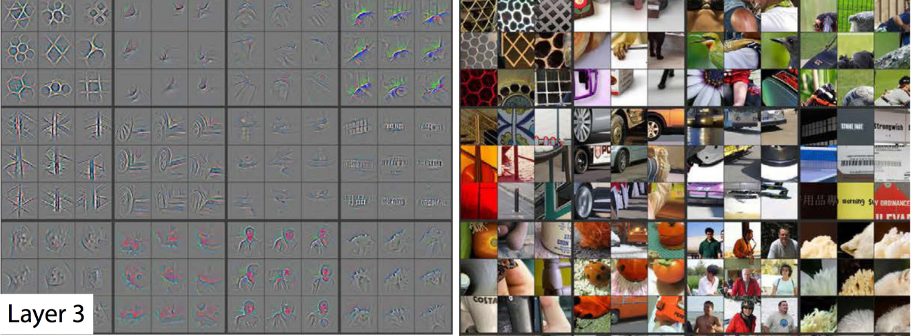

A visualization of the third layer in the CNN. The gray grid on the left represents how this layer of the CNN activates (or "what it sees") based on the corresponding images from the grid on the right.

The third layer picks out complex combinations of features from the second layer. These include things like grids, and honeycombs (top left), wheels (second row, second column), and even faces (third row, third column).

### Layer 5

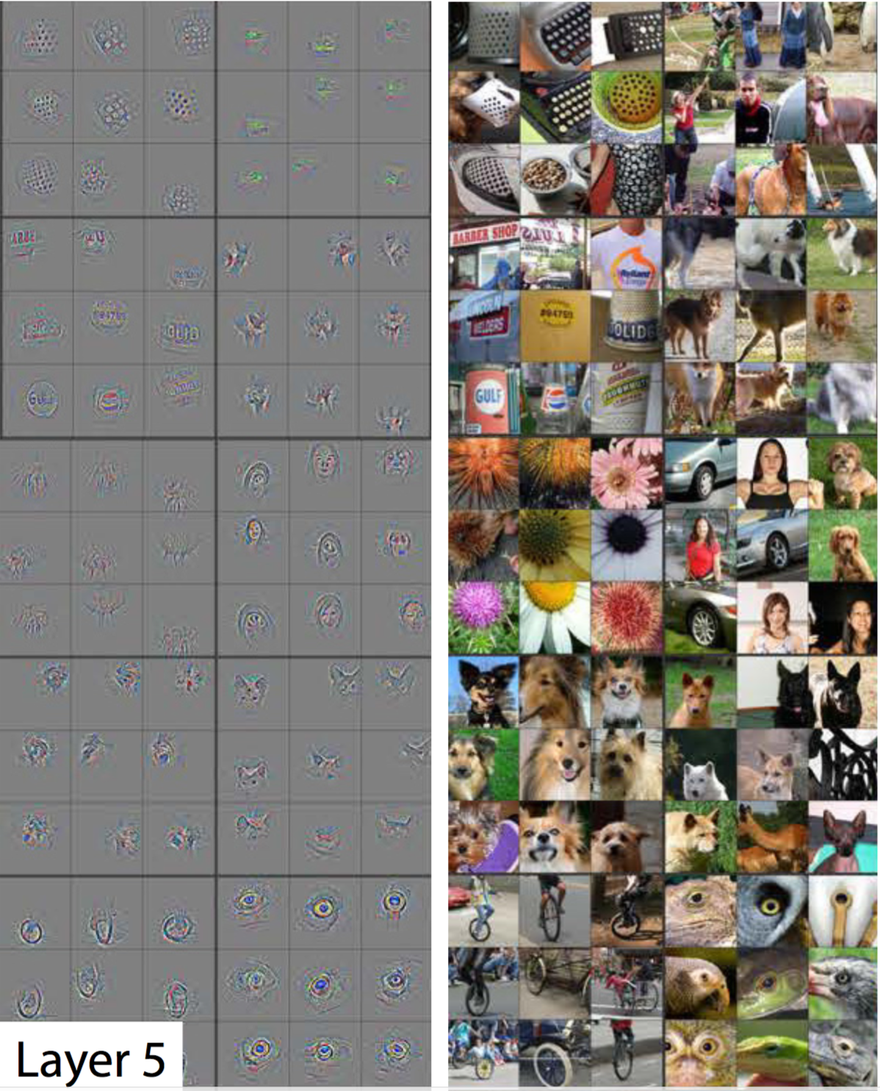

A visualization of the fifth and final layer of the CNN. The gray grid on the left represents how this layer of the CNN activates (or "what it sees") based on the corresponding images from the grid on the right.

We'll skip layer 4, which continues this progression, and jump right to the fifth and final layer of this CNN.

The last layer picks out the highest order ideas that we care about for classification, like dog faces, bird faces, and bicycles.

### On to TensorFlow

This concludes our high-level discussion of Convolutional Neural Networks.

Next you'll practice actually building these networks in TensorFlow.

### TensorFlow Convolution Layer

Let's examine how to implement a CNN in TensorFlow.

TensorFlow provides the [**tf.nn.conv2d()**](https://www.tensorflow.org/api_docs/python/tf/nn/conv2d) and [**tf.nn.bias_add()**](https://www.tensorflow.org/api_docs/python/tf/nn/bias_add) functions to create your own convolutional layers.

*# Output depth*

k_output = 64

*# Image Properties*

image_width = 10

image_height = 10

color_channels = 3

*# Convolution filter*

filter_size_width = 5

filter_size_height = 5

*# Input/Image*

input = tf.placeholder(

tf.float32,

shape=[**None**, image_height, image_width, color_channels])

*# Weight and bias*

weight = tf.Variable(tf.truncated_normal(

[filter_size_height, filter_size_width, color_channels, k_output]))

bias = tf.Variable(tf.zeros(k_output))

*# Apply Convolution*

conv_layer = tf.nn.conv2d(input, weight, strides=[1, 2, 2, 1], padding='SAME')

*# Add bias*

conv_layer = tf.nn.bias_add(conv_layer, bias)

*# Apply activation function*

conv_layer = tf.nn.relu(conv_layer)

The code above uses the [**tf.nn.conv2d()**](https://www.tensorflow.org/api_docs/python/tf/nn/conv2d) function to compute the convolution with weight as the filter and [1, 2, 2, 1] for the strides. TensorFlow uses a stride for each input dimension, [batch, input_height, input_width, input_channels]. We are generally always going to set the stride for batch and input_channels (i.e. the first and fourth element in the strides array) to be 1.

You'll focus on changing input_height and input_width while setting batch and input_channels to 1. The input_height and input_width strides are for striding the filter over input. This example code uses a stride of 2 with 5x5 filter over input.

The [**tf.nn.bias_add()**](https://www.tensorflow.org/api_docs/python/tf/nn/bias_add) function adds a 1-d bias to the last dimension in a matrix.

# TensorFlow Max Pooling



By Aphex34 (Own work) [CC BY-SA 4.0 ([**http://creativecommons.org/licenses/by-sa/4.0**](http://creativecommons.org/licenses/by-sa/4.0))], via Wikimedia Commons

The image above is an example of [**max pooling**](https://en.wikipedia.org/wiki/Convolutional_neural_network#Pooling_layer) with a 2x2 filter and stride of 2. The four 2x2 colors represent each time the filter was applied to find the maximum value.

For example, [[1, 0], [4, 6]] becomes 6, because 6 is the maximum value in this set. Similarly, [[2, 3], [6, 8]] becomes 8.

Conceptually, the benefit of the max pooling operation is to reduce the size of the input, and allow the neural network to focus on only the most important elements. Max pooling does this by only retaining the maximum value for each filtered area, and removing the remaining values.

TensorFlow provides the [**tf.nn.max_pool()**](https://www.tensorflow.org/api_docs/python/tf/nn/max_pool) function to apply [**max pooling**](https://en.wikipedia.org/wiki/Convolutional_neural_network#Pooling_layer) to your convolutional layers.

...

conv_layer = tf.nn.conv2d(input, weight, strides=[1, 2, 2, 1], padding='SAME')

conv_layer = tf.nn.bias_add(conv_layer, bias)

conv_layer = tf.nn.relu(conv_layer)

*# Apply Max Pooling*

conv_layer = tf.nn.max_pool(

conv_layer,

ksize=[1, 2, 2, 1],

strides=[1, 2, 2, 1],

padding='SAME')

The [**tf.nn.max_pool()**](https://www.tensorflow.org/api_docs/python/tf/nn/max_pool) function performs max pooling with the ksize parameter as the size of the filter and the strides parameter as the length of the stride. 2x2 filters with a stride of 2x2 are common in practice.

The [documentation](https://www.tensorflow.org/versions/r0.11/api_docs/python/nn.html#max_pool) is quite clear:

ksize: A list of ints that has length >= 4. The size of the window for each dimension of the input tensor.

In general for images, your input is of shape [batch_size, 64, 64, 3] for an RGB image of 64x64 pixels.

The kernel size ksize will typically be [1, 2, 2, 1] if you have a 2x2 window over which you take the maximum. On the batch size dimension and the channels dimension, ksize is 1because we don't want to take the maximum over multiple examples, or over multiples channels.

The ksize and strides parameters are structured as 4-element lists, with each element corresponding to a dimension of the input tensor ([batch, height, width, channels]). For both ksize and strides, the batch and channel dimensions are typically set to 1.

### Solution

The correct answer is **decrease the size of the output** and **prevent overfitting**. Preventing overfitting is a consequence of reducing the output size, which in turn, reduces the number of parameters in future layers.

Recently, pooling layers have fallen out of favor. Some reasons are:

* Recent datasets are so big and complex we're more concerned about underfitting.
* Dropout is a much better regularizer.
* Pooling results in a loss of information. Think about the max pooling operation as an example. We only keep the largest of n numbers, thereby disregarding n-1 numbers completely.

### Setup

H = height, W = width, D = depth

* We have an input of shape 4x4x5 (HxWxD)
* Filter of shape 2x2 (HxW)
* A stride of 2 for both the height and width (S)

Recall the formula for calculating the new height or width:

new_height = (input_height - filter_height)/S + 1

new_width = (input_width - filter_width)/S + 1

NOTE: For a pooling layer the output depth is the same as the input depth. Additionally, the pooling operation is applied individually for each depth slice.

The image below gives an example of how a max pooling layer works. In this case, the max pooling filter has a shape of 2x2. As the max pooling filter slides across the input layer, the filter will output the maximum value of the 2x2 square.

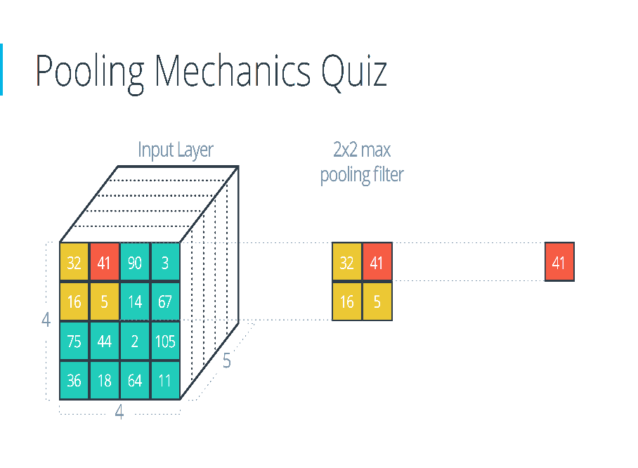

### Solution

The answer is **2x2x5**. Here's how it's calculated using the formula:

(4 - 2)/2 + 1 = 2

(4 - 2)/2 + 1 = 2

The depth stays the same.

Here's the corresponding code:

input = tf.placeholder(tf.float32, (**None**, 4, 4, 5))

filter_shape = [1, 2, 2, 1]

strides = [1, 2, 2, 1]

padding = 'VALID'

pool = tf.nn.max_pool(input, filter_shape, strides, padding)

The output shape of pool will be [1, 2, 2, 5], even if padding is changed to 'SAME'.

## Max Pooling

What's the result of a **max pooling** operation on the input:

[[[0, 1, 0.5, 10],

[2, 2.5, 1, -8],

[4, 0, 5, 6],

[15, 1, 2, 3]]]

Assume the filter is 2x2 and the stride is 2 for both height and width. The output shape is 2x2x1.

The answering format will be 4 numbers, each separated by a comma, such as: 1,2,3,4.

**Work from the top left to the bottom right**

### Solution

The correct answer is 2.5,10,15,6. We start with the four numbers in the top left corner. Then we work left-to-right and top-to-bottom, moving 2 units each time.

max(0, 1, 2, 2.5) = 2.5

max(0.5, 10, 1, -8) = 10

max(4, 0, 15, 1) = 15

max(5, 6, 2, 3) = 6

2.5, 10, 15, 6

# Convolutional Network in TensorFlow

It's time to walk through an example Convolutional Neural Network (CNN) in TensorFlow.

The structure of this network follows the classic structure of CNNs, which is a mix of convolutional layers and max pooling, followed by fully-connected layers.

The code you'll be looking at is similar to what you saw in the segment on [**Deep Neural Network in TensorFlow**](https://classroom.udacity.com/nanodegrees/nd101/parts/2a9dba0b-28eb-4b0e-acfa-bdcf35680d90/modules/ca299d5f-35f6-4520-a2b0-74c6878008b3/lessons/bd73c076-7661-4947-9f73-7020d313eb6f/concepts/83a3a2a2-a9bd-4b7b-95b0-eb924ab14432), except we restructured the architecture of this network as a CNN.

Just like in that segment, here you'll study the line-by-line breakdown of the code. If you want, you can even [**download the code**](https://d17h27t6h515a5.cloudfront.net/topher/2017/February/58a61ca1_cnn/cnn.zip) and run it yourself.

Thanks to [**Aymeric Damien**](https://github.com/aymericdamien/TensorFlow-Examples) for providing the original TensorFlow model on which this segment is based.

Time to dive in!

### Dataset

You've seen this section of code from previous lessons. Here we're importing the MNIST dataset and using a convenient TensorFlow function to batch, scale, and One-Hot encode the data.

**from** tensorflow.examples.tutorials.mnist **import** input_data

mnist = input_data.read_data_sets(".", one_hot=**True**, reshape=**False**)

**import** tensorflow **as** tf

*# Parameters*

learning_rate = 0.00001

epochs = 10

batch_size = 128

*# Number of samples to calculate validation and accuracy*

*# Decrease this if you're running out of memory to calculate accuracy*

test_valid_size = 256

*# Network Parameters*

n_classes = 10 *# MNIST total classes (0-9 digits)*

dropout = 0.75 *# Dropout, probability to keep units*

### Weights and Biases

*# Store layers weight & bias*

weights = {

'wc1': tf.Variable(tf.random_normal([5, 5, 1, 32])),

'wc2': tf.Variable(tf.random_normal([5, 5, 32, 64])),

'wd1': tf.Variable(tf.random_normal([7*7*64, 1024])),

'out': tf.Variable(tf.random_normal([1024, n_classes]))}

biases = {

'bc1': tf.Variable(tf.random_normal([32])),

'bc2': tf.Variable(tf.random_normal([64])),

'bd1': tf.Variable(tf.random_normal([1024])),

'out': tf.Variable(tf.random_normal([n_classes]))}

### Convolutions



Convolution with 3×3 Filter. Source: [**http://deeplearning.stanford.edu/wiki/index.php/Feature_extraction_using_convolution**](http://deeplearning.stanford.edu/wiki/index.php/Feature_extraction_using_convolution)

The above is an example of a [**convolution**](https://en.wikipedia.org/wiki/Convolution) with a 3x3 filter and a stride of 1 being applied to data with a range of 0 to 1. The convolution for each 3x3 section is calculated against the weight, [[1, 0, 1], [0, 1, 0], [1, 0, 1]], then a bias is added to create the convolved feature on the right. In this case, the bias is zero. In TensorFlow, this is all done using [**tf.nn.conv2d()**](https://www.tensorflow.org/api_docs/python/tf/nn/conv2d) and [**tf.nn.bias_add()**](https://www.tensorflow.org/api_docs/python/tf/nn/bias_add).

**def** **conv2d**(x, W, b, strides=1):

x = tf.nn.conv2d(x, W, strides=[1, strides, strides, 1], padding='SAME')

x = tf.nn.bias_add(x, b)

**return** tf.nn.relu(x)

The [**tf.nn.conv2d()**](https://www.tensorflow.org/api_docs/python/tf/nn/conv2d) function computes the convolution against weight W as shown above.

In TensorFlow, strides is an array of 4 elements; the first element in this array indicates the stride for batch and last element indicates stride for features. It's good practice to remove the batches or features you want to skip from the data set rather than use a stride to skip them. You can always set the first and last element to 1 in strides in order to use all batches and features.

The middle two elements are the strides for height and width respectively. I've mentioned stride as one number because you usually have a square stride where height = width. When someone says they are using a stride of 3, they usually mean tf.nn.conv2d(x, W, strides=[1, 3, 3, 1]).

To make life easier, the code is using [**tf.nn.bias_add()**](https://www.tensorflow.org/api_docs/python/tf/nn/bias_add) to add the bias. Using [**tf.add()**](https://www.tensorflow.org/api_docs/python/tf/add) doesn't work when the tensors aren't the same shape.

### Max Pooling

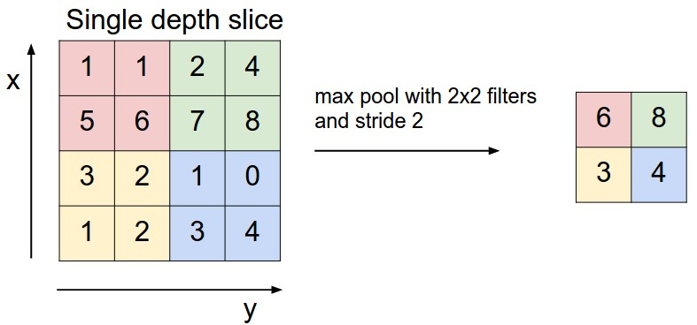

Max Pooling with 2x2 filter and stride of 2. Source: [**http://cs231n.github.io/convolutional-networks/**](http://cs231n.github.io/convolutional-networks/)

The above is an example of [**max pooling**](https://en.wikipedia.org/wiki/Convolutional_neural_network#Pooling_layer) with a 2x2 filter and stride of 2. The left square is the input and the right square is the output. The four 2x2 colors in input represents each time the filter was applied to create the max on the right side. For example, [[1, 1], [5, 6]] becomes 6 and [[3, 2], [1, 2]] becomes 3.

**def** **maxpool2d**(x, k=2):

**return** tf.nn.max_pool(

x,

ksize=[1, k, k, 1],

strides=[1, k, k, 1],

padding='SAME')

The [**tf.nn.max_pool()**](https://www.tensorflow.org/api_docs/python/tf/nn/max_pool) function does exactly what you would expect, it performs max pooling with the ksize parameter as the size of the filter.

### Model

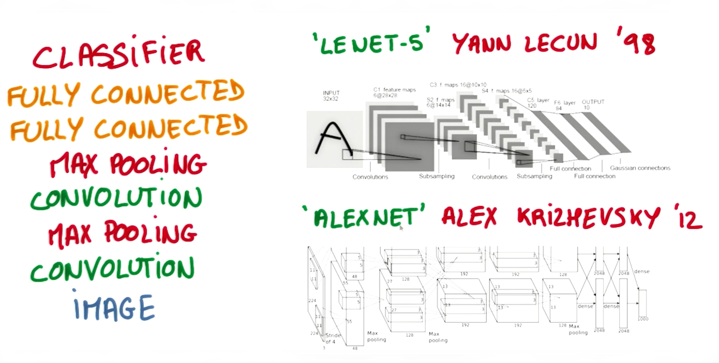

Image from Explore The Design Space video

In the code below, we're creating 3 layers alternating between convolutions and max pooling followed by a fully connected and output layer. The transformation of each layer to new dimensions are shown in the comments. For example, the first layer shapes the images from 28x28x1 to 28x28x32 in the convolution step [STRIDE = default = 1]. Then next step applies max pooling, turning each sample into 14x14x32 [STRIDE = 2]. All the layers are applied from conv1to output, producing 10 class predictions.

**def** **conv_net**(x, weights, biases, dropout):

*# Layer 1 - 28*28*1 to 14*14*32*

conv1 = conv2d(x, weights['wc1'], biases['bc1'])

conv1 = maxpool2d(conv1, k=2)

*# Layer 2 - 14*14*32 to 7*7*64*

conv2 = conv2d(conv1, weights['wc2'], biases['bc2'])

conv2 = maxpool2d(conv2, k=2)

*# Fully connected layer - 7*7*64 to 1024*

fc1 = tf.reshape(conv2, [-1, weights['wd1'].get_shape().as_list()[0]])

<https://www.tensorflow.org/api_docs/python/tf/reshape>

fc1 = tf.add(tf.matmul(fc1, weights['wd1']), biases['bd1'])

fc1 = tf.nn.relu(fc1)

fc1 = tf.nn.dropout(fc1, dropout)

*# Output Layer - class prediction - 1024 to 10*

out = tf.add(tf.matmul(fc1, weights['out']), biases['out'])

**return** out

### Session

Now let's run it!

*# tf Graph input*

x = tf.placeholder(tf.float32, [**None**, 28, 28, 1])

y = tf.placeholder(tf.float32, [**None**, n_classes])

keep_prob = tf.placeholder(tf.float32)

*# Model*

logits = conv_net(x, weights, biases, keep_prob)

*# Define loss and optimizer*

cost = tf.reduce_mean(\

tf.nn.softmax_cross_entropy_with_logits(logits=logits, labels=y))

optimizer = tf.train.GradientDescentOptimizer(learning_rate=learning_rate)\

.minimize(cost)

*# Accuracy*

correct_pred = tf.equal(tf.argmax(logits, 1), tf.argmax(y, 1))

accuracy = tf.reduce_mean(tf.cast(correct_pred, tf.float32))

*# Initializing the variables*

init = tf. global_variables_initializer()

*# Launch the graph*

**with** tf.Session() **as** sess:

sess.run(init)

**for** epoch **in** range(epochs):

**for** batch **in** range(mnist.train.num_examples//batch_size):

batch_x, batch_y = mnist.train.next_batch(batch_size)

sess.run(optimizer, feed_dict={

x: batch_x,

y: batch_y,

keep_prob: dropout})

*# Calculate batch loss and accuracy*

loss = sess.run(cost, feed_dict={

x: batch_x,

y: batch_y,

keep_prob: 1.})

valid_acc = sess.run(accuracy, feed_dict={

x: mnist.validation.images[:test_valid_size],

y: mnist.validation.labels[:test_valid_size],

keep_prob: 1.})

print('Epoch {:>2}, Batch {:>3} -'

'Loss: {:>10.4f} Validation Accuracy: {:.6f}'.format(

epoch + 1,

batch + 1,

loss,

valid_acc))

*# Calculate Test Accuracy*

test_acc = sess.run(accuracy, feed_dict={

x: mnist.test.images[:test_valid_size],

y: mnist.test.labels[:test_valid_size],

keep_prob: 1.})

print('Testing Accuracy: {}'.format(test_acc))

That's it! That is a CNN in TensorFlow. Now that you've seen a CNN in TensorFlow, let's see if you can apply it on your own!

### Using Convolution Layers in TensorFlow

Let's now apply what we've learned to build real CNNs in TensorFlow. In the below exercise, you'll be asked to set up the dimensions of the Convolution filters, the weights, the biases. This is in many ways the trickiest part to using CNNs in TensorFlow. Once you have a sense of how to set up the dimensions of these attributes, applying CNNs will be far more straight forward.

### Review

You should go over the TensorFlow documentation for [**2D convolutions**](https://www.tensorflow.org/api_guides/python/nn#Convolution). Most of the documentation is straightforward, except perhaps the padding argument. The padding might differ depending on whether you pass 'VALID' or 'SAME'.

Here are a few more things worth reviewing:

1. [**TensorFlow Variables**](https://classroom.udacity.com/nanodegrees/nd101/parts/2a9dba0b-28eb-4b0e-acfa-bdcf35680d90/modules/43289903-8d8b-49fb-9a19-5baa4aabc2d7/lessons/6ec4ffd6-4f5c-4b88-bdf6-f169119834f0/concepts/baf36422-c1b4-4005-960f-63a550e635d4).
2. [**Truncated Normal Distributions**](https://classroom.udacity.com/nanodegrees/nd101/parts/2a9dba0b-28eb-4b0e-acfa-bdcf35680d90/modules/43289903-8d8b-49fb-9a19-5baa4aabc2d7/lessons/6ec4ffd6-4f5c-4b88-bdf6-f169119834f0/concepts/baf36422-c1b4-4005-960f-63a550e635d4) in TensorFlow (you'll want to initialize your weights with a truncated normal distribution).
3. How to determine the dimensions of the output based on the input size and the filter size (shown below). You'll use this to determine what the size of your filter should be.
4. new_height = (input_height - filter_height + 2 * P)/S + 1
5. new_width = (input_width - filter_width + 2 * P)/S + 1

### Instructions

1. Finish off each TODO in the conv2d function.
2. Setup the strides, padding and filter weight/bias (F_w and F_b) such that the output shape is (1, 2, 2, 3). Note that all of these except strides should be TensorFlow variables.

"""

Setup the strides, padding and filter weight/bias such that

the output shape is (1, 2, 2, 3).

"""

import tensorflow as tf

import numpy as np

# `tf.nn.conv2d` requires the input be 4D (batch_size, height, width, depth)

# (1, 4, 4, 1)

x = np.array([

[0, 1, 0.5, 10],

[2, 2.5, 1, -8],

[4, 0, 5, 6],

[15, 1, 2, 3]], dtype=np.float32).reshape((1, 4, 4, 1))

X = tf.constant(x)

def conv2d(input):

# Filter (weights and bias)

# The shape of the filter weight is (height, width, input_depth, output_depth)

# The shape of the filter bias is (output_depth,)

# TODO: Define the filter weights `F_W` and filter bias `F_b`.

# NOTE: Remember to wrap them in `tf.Variable`, they are trainable parameters after all.

'''

the desired output shape is (1, 2, 2, 3)

note output depth = 3

'''

F_W = tf.Variable(tf.truncated_normal([4, 4, 1, 3])) ##tf.Variable(4, 4, 1, 3)

F_b = tf.Variable(tf.truncated_normal([3]))

# TODO: Set the stride for each dimension (batch_size, height, width, depth)

strides = [1, 2, 2, 1]

## why 2,2 since i need to go from 4,4 => 2,2

# TODO: set the padding, either 'VALID' or 'SAME'.

padding = 'SAME'

# https://www.tensorflow.org/versions/r0.11/api_docs/python/nn.html#conv2d

# `tf.nn.conv2d` does not include the bias computation so we have to add it ourselves after.

return tf.nn.conv2d(input, F_W, strides, padding) + F_b

out = conv2d(X)

<http://stackoverflow.com/questions/37674306/what-is-the-difference-between-same-and-valid-padding-in-tf-nn-max-pool-of-t>

|  |  |
| --- | --- |
| up vote26down vote[favorite](http://stackoverflow.com/questions/37674306/what-is-the-difference-between-same-and-valid-padding-in-tf-nn-max-pool-of-t)  15 | What is the difference between 'SAME' and 'VALID' padding in tf.nn.max_pool of tensorflow?  In my opinion, 'VALID' means there will be no zero padding outside the edges when we do max pool.  According to [A guide to convolution arithmetic for deep learning](https://arxiv.org/pdf/1603.07285v1.pdf), it says that there will be no padding in pool operator, i.e. just use 'VALID' of tensorflow. But what is 'SAME' padding of max pool in tensorflow?  [python](http://stackoverflow.com/questions/tagged/python) [tensorflow](http://stackoverflow.com/questions/tagged/tensorflow) [deep-learning](http://stackoverflow.com/questions/tagged/deep-learning) |
|  |  |

## **5 Answers**

[active](http://stackoverflow.com/questions/37674306/what-is-the-difference-between-same-and-valid-padding-in-tf-nn-max-pool-of-t?answertab=active#tab-top)[oldest](http://stackoverflow.com/questions/37674306/what-is-the-difference-between-same-and-valid-padding-in-tf-nn-max-pool-of-t?answertab=oldest#tab-top)[votes](http://stackoverflow.com/questions/37674306/what-is-the-difference-between-same-and-valid-padding-in-tf-nn-max-pool-of-t?answertab=votes#tab-top)

|  |  |  |  |
| --- | --- | --- | --- |
| up vote14down voteaccepted | I'll give an example to make it clearer:   * x: input image of shape [2, 3], 1 channel * valid_pad: max pool with 2x2 kernel, stride 2 and VALID padding. * same_pad: max pool with 2x2 kernel, stride 2 and SAME padding (this is the **classic** way to go)   The output shapes are:   * valid_pad: here, no padding so the output shape is [1, 1] * same_pad: here, we pad the image to the shape [2, 4] (with -inf and then apply max pool), so the output shape is [1, 2]   x = tf.constant([[1., 2., 3.],  [4., 5., 6.]])  x = tf.reshape(x, [1, 2, 3, 1]) # give a shape accepted by tf.nn.max_pool  valid_pad = tf.nn.max_pool(x, [1, 2, 2, 1], [1, 2, 2, 1], padding='VALID')  same_pad = tf.nn.max_pool(x, [1, 2, 2, 1], [1, 2, 2, 1], padding='SAME')  valid_pad.get_shape() == [1, 1, 1, 1] # valid_pad is [5.]  same_pad.get_shape() == [1, 1, 2, 1] # same_pad is [5., 6.]   |  |  | | --- | --- | | [share](http://stackoverflow.com/a/37675359)[improve this answer](http://stackoverflow.com/posts/37675359/edit) | answered Jun 7 '16 at 9:22  [[https://www.gravatar.com/avatar/73fd0f3587eec2e8ac9e13726a84e11e?s=32&d=identicon&r=PG&f=1](http://stackoverflow.com/users/5098368/olivier-moindrot)](http://stackoverflow.com/users/5098368/olivier-moindrot)  [Olivier Moindrot](http://stackoverflow.com/users/5098368/olivier-moindrot)  **6,241**21236 | |
|  | add a comment |
| up vote56down vote | If you like ascii art:   * "VALID" = without padding:   inputs: 1 2 3 4 5 6 7 8 9 10 11 (12 13)  |________________| dropped  |_________________|   * "SAME" = with zero padding:   pad| |pad  inputs: 0 |1 2 3 4 5 6 7 8 9 10 11 12 13|0 0  |________________|  |_________________|  |________________|  In this example:   * Input width = 13 * Filter width = 6 * Stride = 5   Notes:   * "VALID" only ever drops the right-most columns (or bottom-most rows). * "SAME" tries to pad evenly left and right, but if the amount of columns to be added is odd, it will add the extra column to the right, as is the case in this example (the same logic applies vertically: there may be an extra row of zeros at the bottom).  |  |  |  | | --- | --- | --- | | [share](http://stackoverflow.com/a/39371113)[improve this answer](http://stackoverflow.com/posts/39371113/edit) | [edited Sep 7 '16 at 13:29](http://stackoverflow.com/posts/39371113/revisions) | answered Sep 7 '16 at 13:22  [[https://www.gravatar.com/avatar/0c1235b75e5f26b854dce060f906d2dc?s=32&d=identicon&r=PG](http://stackoverflow.com/users/38626/miniquark)](http://stackoverflow.com/users/38626/miniquark)  [MiniQuark](http://stackoverflow.com/users/38626/miniquark)  **14.5k**1484118 | |
|  | |  |  |  |  | | --- | --- | --- | --- | | |  |  | | --- | --- | | 2 |  | | Very intuitive answer, thanks! – [gcucurull](http://stackoverflow.com/users/1738214/gcucurull) [Sep 14 '16 at 8:50](http://stackoverflow.com/questions/37674306/what-is-the-difference-between-same-and-valid-padding-in-tf-nn-max-pool-of-t#comment66290580_39371113) | | |  |  | | --- | --- | |  |  | | I tought the output and input sizes should be same in SAME padding, but it seems the input size is 13 and output size is 3? – [LoveMeow](http://stackoverflow.com/users/723597/lovemeow) [Nov 22 '16 at 10:55](http://stackoverflow.com/questions/37674306/what-is-the-difference-between-same-and-valid-padding-in-tf-nn-max-pool-of-t#comment68705787_39371113) | | |  |  | | --- | --- | | 2 |  | | @LoveMeow You are right when the stride is equal to 1, but when it is 2 or more, the output size is smaller. – [MiniQuark](http://stackoverflow.com/users/38626/miniquark) [Nov 22 '16 at 11:08](http://stackoverflow.com/questions/37674306/what-is-the-difference-between-same-and-valid-padding-in-tf-nn-max-pool-of-t#comment68706380_39371113) |   add a comment |

|  |  |
| --- | --- |
| up vote9down vote | The [TensorFlow Convolution](https://www.tensorflow.org/versions/r0.9/api_docs/python/nn.html) example gives an overview about the difference between SAME and VALID :   * For the SAME padding, the output height and width are computed as:   out_height = ceil(float(in_height) / float(strides[1](https://www.tensorflow.org/versions/r0.9/api_docs/python/nn.html)))  out_width = ceil(float(in_width) / float(strides[2]))  And   * For the VALID padding, the output height and width are computed as:   out_height = ceil(float(in_height - filter_height + 1) / float(strides[1](https://www.tensorflow.org/versions/r0.9/api_docs/python/nn.html)))  out_width = ceil(float(in_width - filter_width + 1) / float(strides[2])) |
|  | |  |  |  |  | | --- | --- | --- | --- | | |  |  | | --- | --- | |  |  | | It is the conv2d padding, Is it the same with the padding in max_pool? – [karl_TUM](http://stackoverflow.com/users/5651936/karl-tum) [Jun 7 '16 at 9:07](http://stackoverflow.com/questions/37674306/what-is-the-difference-between-same-and-valid-padding-in-tf-nn-max-pool-of-t#comment62827258_37674568) | | |  |  | | --- | --- | |  |  | | It is only one padding algorithm, please refer to the link I have mentioned , you'll understand more. – [Tristan](http://stackoverflow.com/users/6154787/tristan)[Jun 7 '16 at 9:08](http://stackoverflow.com/questions/37674306/what-is-the-difference-between-same-and-valid-padding-in-tf-nn-max-pool-of-t#comment62827308_37674568) | | |  |  | | --- | --- | |  |  | | Thank you very much. – [karl_TUM](http://stackoverflow.com/users/5651936/karl-tum) [Jun 7 '16 at 9:38](http://stackoverflow.com/questions/37674306/what-is-the-difference-between-same-and-valid-padding-in-tf-nn-max-pool-of-t#comment62828575_37674568) | |

### Additional Resources

There are many wonderful free resources that allow you to go into more depth around Convolutional Neural Networks. In this course, our goal is to give you just enough intuition to start applying this concept on real world problems so you have enough of an exposure to explore more on your own. We strongly encourage you to explore some of these resources more to reinforce your intuition and explore different ideas.

These are the resources we recommend in particular:

* Andrej Karpathy's [**CS231n Stanford course**](http://cs231n.github.io/) on Convolutional Neural Networks.
* Michael Nielsen's [**free book**](http://neuralnetworksanddeeplearning.com/) on Deep Learning.
* Goodfellow, Bengio, and Courville's more advanced [**free book**](http://deeplearningbook.org/) on Deep Learning.